1. Go to this website:

https://issues.apache.org/jira/secure/Dashboard.jspa

1. Find the list of software projects:

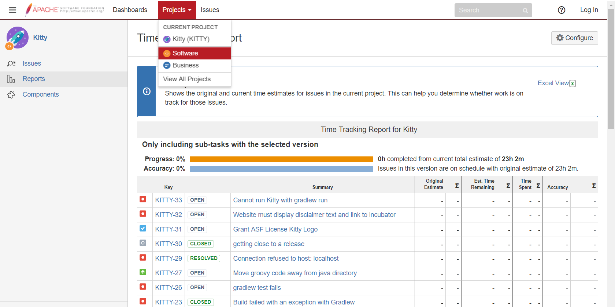

1. Search the project by the project name in the file list.

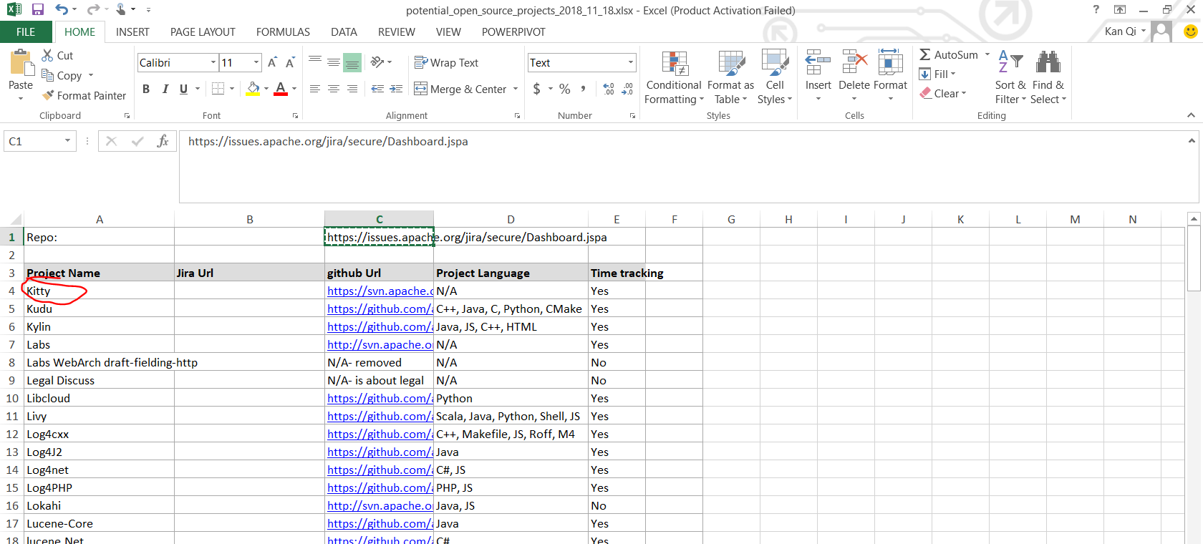

1. Fill the Jira Url field.

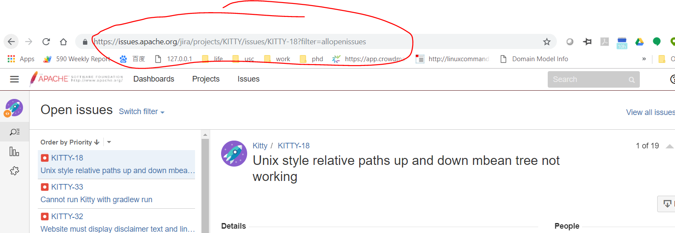

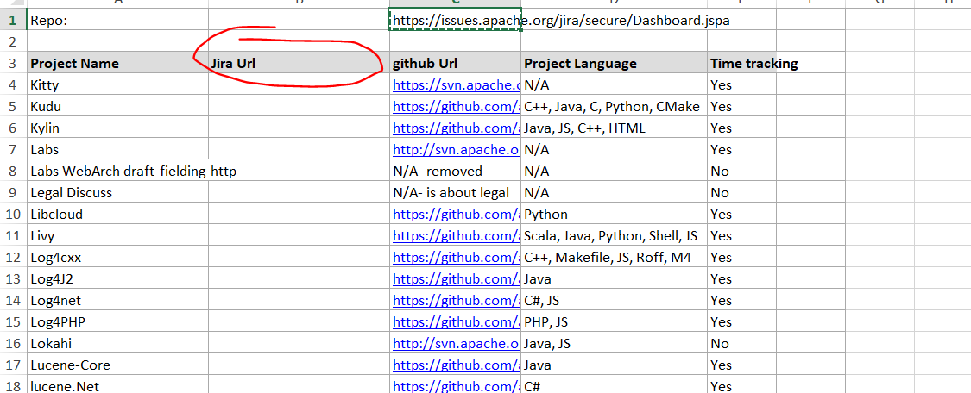

1. Fill out the estimates for the hours.

